Ⅶ. Cost Estimation

**Assumption**

* Users number

To assess scalability, we calculate cost on three users tiers:

1,000 / 10,000 1,000,000 (1 million) users

* Time period

Assume the new health insurance program need 30 days to collect images from one user.

* Number of images

Assume there will be 1 image for 1 meal of 1 user. Then the total number of images on three user tiers would be 90,000 / 900,000 / 90,000,000

* Avg. size of images

Considering the size of original photos taken by cameras and phones, we think the average size of images is 1MB.

**Services**

In this cost analysis section, we calculate cost on AWS Services, including Lambda, S3 storage, S3 Request,  API Gateway, and EC2; cost by calling Amazon Rekognition API, Google Vision API, and Azure Computer Vision API; labor cost including developing, deploying, maintaining, and training fee.

For system developing and deploying, since the AWS is able to conduct auto scaling, we will only consider developing once. It is $90,000 (see below). The rest of cost considering this goes to maintenance cost.

**Chart of  Cost for one-month based on three tiers**

|  |  |  |  |  |  |
| --- | --- | --- | --- | --- | --- |
| Category | Service | Price | | | Subtotal |
| API | Amazon Rekognition API | 1,000 users | 10,000 users | 1 million users | 1st tier: $313.5  2nd tier: $3,135  3ed tier: $210k |
| $90 | $900 | $58,562 |
| Google Vision API | $133.5 | $1,335 | $92,500 |
| Microsoft | $90 | $900 | $58,500 |
| Amazon Web Service | Lambda | $0 | $0.16 | $213 | 1st tier: $15k  2nd tier: $15k  3ed tier: $33k |
| S3 Storage | $1.1 | $11.26 | $1,125 |
| S3 Request | $0.88 | $8.8 | $880 |
| API Gateway | $3.5 | $3.5 | $7.0 |
| EC2 | $15,298 | $15,298 | $31,104 |
| Labor | Training Fee | $4.3 | $4.3 | $8.6 | $4.3; $4.3; $8.6 |
| Maintaining | $0 | $0 | $1,500 | 0; 0; $1,500 |
| Total | | $15k | $18k | $244k | - |

**Explanations**

* Amazon Recognition API:

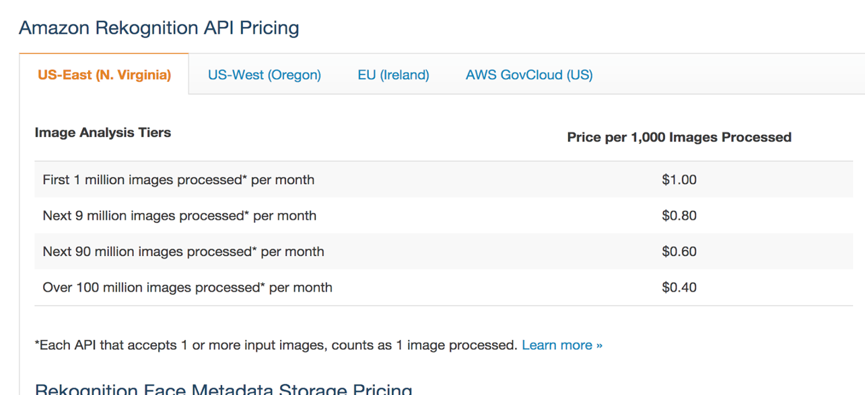

Number of images on three user tiers are 90,000 / 900,000 / 90,000,000. For tiers with less than 1 million images, our system will be using first pricing tier. For one million users, we use the ladder price.

Total cost: $90 / $900 / ($1 * 1,000 + $0.8 * 9,000 + $0.6 * 80,000 = $56,200)

* Google Vision API:

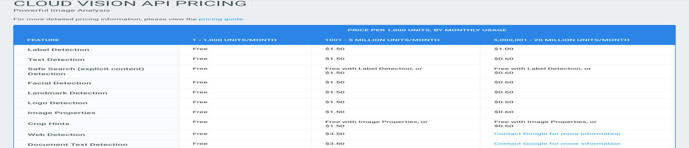

Our system will only use Label Detection Service for Google Vision API.

Number of images on three user tiers are 90,000 / 900,000 / 90,000,000 .

Cost: $133.5 / $1335 / ($85,000 + $7500 = $92,500)

* Azure API:

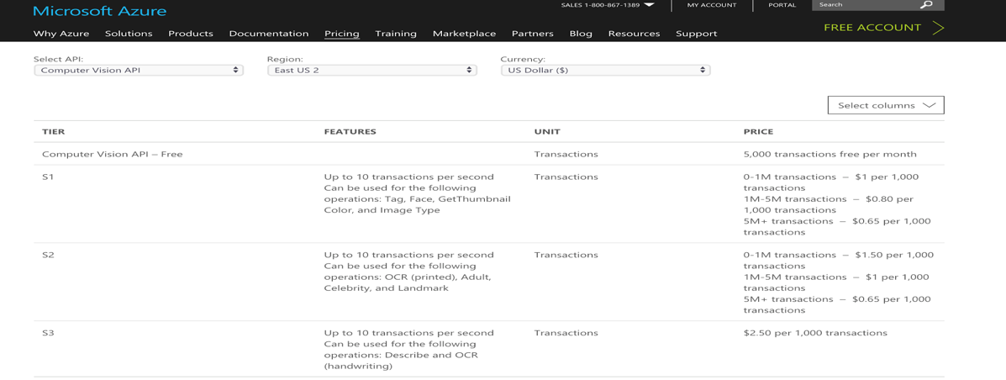

For tags detect service, we will be using S1 tier service of Azure Computer Vision API.

Number of images on three user tiers are 90,000 / 900,000 / 90,000,000.

Cost: $90 / $900 / $58,500

* Lambda Function

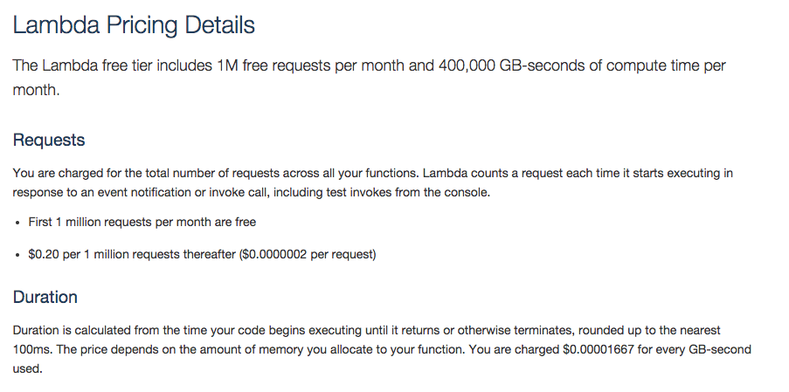

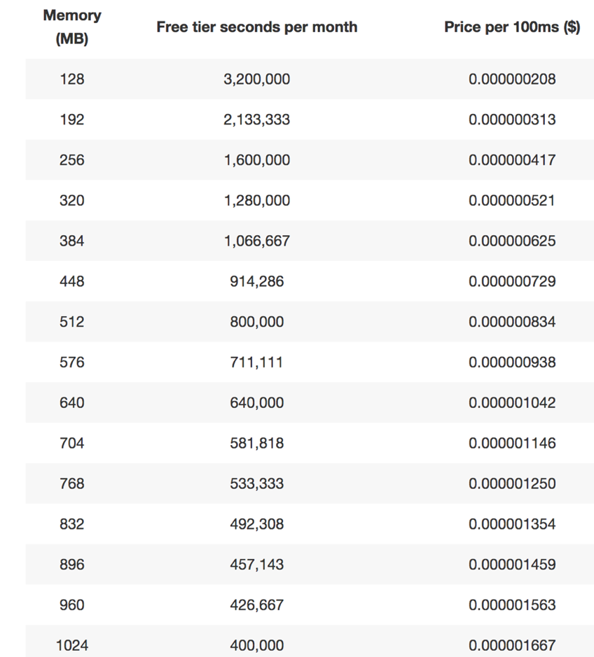

The total cost on the Lambda Function is compute charges plus request charges.

Our code is about 120MB. We need to allocate 128MB of memory to the lambda function. This has nothing to do with the user number. We have 2 Lambda for process each image, so we will execute 180,000 / 1,800,000 / 180,000,000  times in one month, and it ran for 500ms each time.

(a). Compute charges

The monthly compute price is $0.00001667 per GB-s and the free tier provides 400,000 GB-s.

Total compute = (180,000 / 1.8M/ 180M) * (0.5s) = (90,000 / 0.9M / 90M) seconds

= (90,000 / 0.9M / 90M)  * 128/1024 = (11,250 / 112,500 / 11M) GB-s

The first two tier is free. Monthly billable compute GB- s for the third tier is 10.6M

Monthly compute charges = 10.6M * $0.00001667 = $177

(b). Monthly request charges

The monthly request price is $0.20 per 1 million requests and the free tier provides 1M requests per month.

Total requests – Free tier requests = Monthly billable requests

Total request charges: Free / 0.8M * $0.2 / 179M * 0.2 =  free / $0.16 / $35.8

(c).Total charges

Total monthly charges = free / $0.16 / $213

* S3 Storage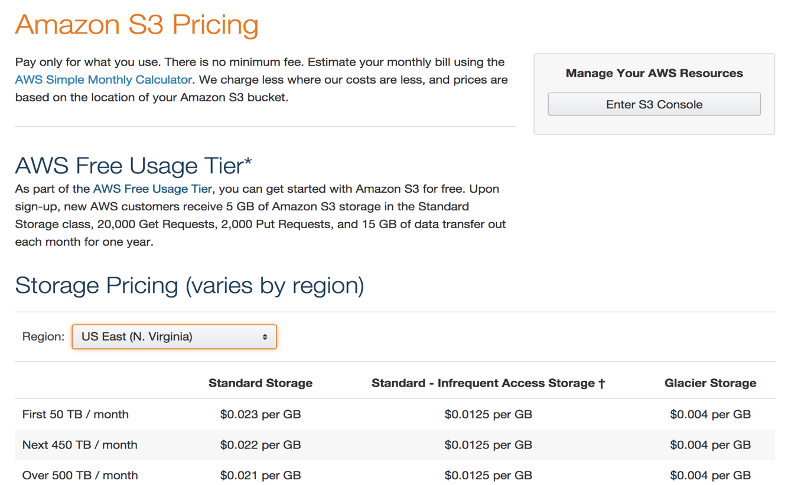

Our system uses S3 bucket for two purposes: store images and image scores.

(a). For images

According to our assumption, the average size images is 1MB. So the total storage of images in one month on three tiers would be 88GB / 0.9 TB / 90 TB. Because we will access images in S3 bucket at most once a month, infrequent Access Storage would be enough. Cost: $1.1 / $11.25 / $1125

(b). For image scores

One score (one image) will take 16 bytes memory. One user will have 90 scores in month. The the memory needed for three user-tier would be around 1.4 MB / 14 MB /1.4 GB.

Total cost on S3 storage: $1.1 / $11.26 / $1,125

* S3 Request Pricing Charges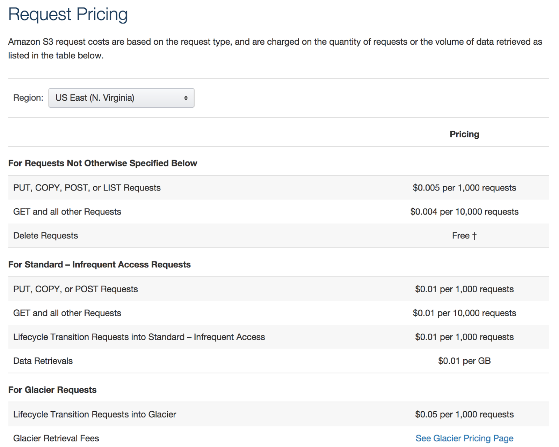

We will be using data retrieval service.

For 1,000 user, we need 88GB + 1.4MB, the cost would be $0.88

For 10,000 and 1 million users, it would be $8.8 and $880

* AWS API Gateway

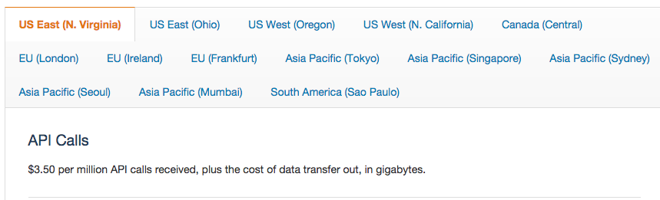

For one user, our system will make 2 API calls.

Total cost for three user-level tiers: $3.5 / $3.5 / $7.0

* EC2

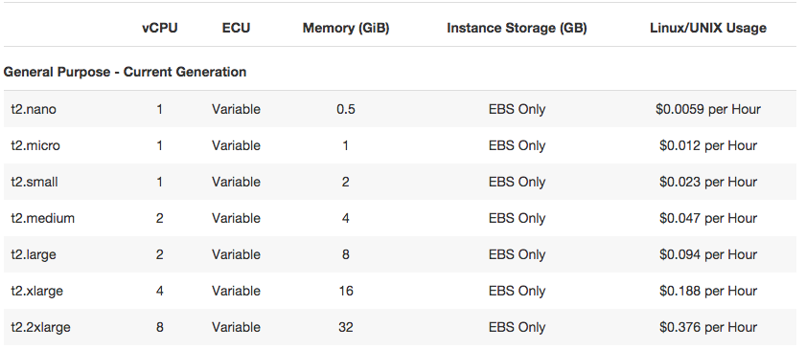

According to the recommended use cases of EC2 instances, we will use T2 instances for web applications. For 1,000 and 100,000 users, we use t2.nano. When the user population grows to one million, the AWS will execute horizontal scaling and we assume the system will be using a t2.small instance then.

For one month, the instance need to run every second, that’s 2,592,000 seconds.

Cost: $0.0059 * 2,592,000 = $15,298; $0.012 * 2,592,000 = $31,104

* Developing - one time fee

We use experienced estimation method. Assume the system is a 1 man-year work, and the maintenance cost each year is 20% of total cost.

The average salary of software engineers is $90,000. Then the developing cost would $90,000.

* Maintenance

Suppose our system will only need considerable maintenance fee when it comes to million-level users. According to the developing cost, the monthly maintenance fee:

$90,000 / 12 * 0.2 =  $1,500

* Labor

Training Fee

Since our system is user friendly, we only need a two-our workshop once a year to teach UPMC staff to use our system if we have 1,000 or 10,000 users. Assume the trainer work 50 weeks a year and 8 hour per day. According to Glassdoor, the average salary for technical trainer is $53,381. Then the hourly wage is $26. Since training fee is a one-time fee, the total cost would be $26 * 2 = $52 for a year.

Assume UPMC will first launch our system with 1,000 to 10,000 users, and then scale horizontally to 1,000,000 users. We will have another 2-hour workshop then.